**Name: Shaikh Rauf Yoosaf Roll No: 18CO55**

**Subject: Web Development Lab**

**Class: TECO**

**Exp No**: **9**

# Aim: Hosting the website with Domain Registration Process.

**Screenshots:**

1. **Domain Registration**

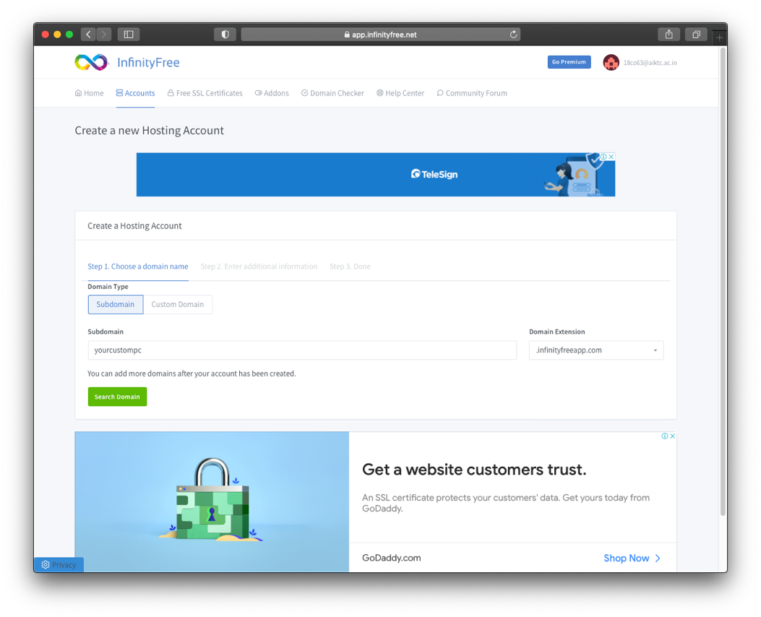

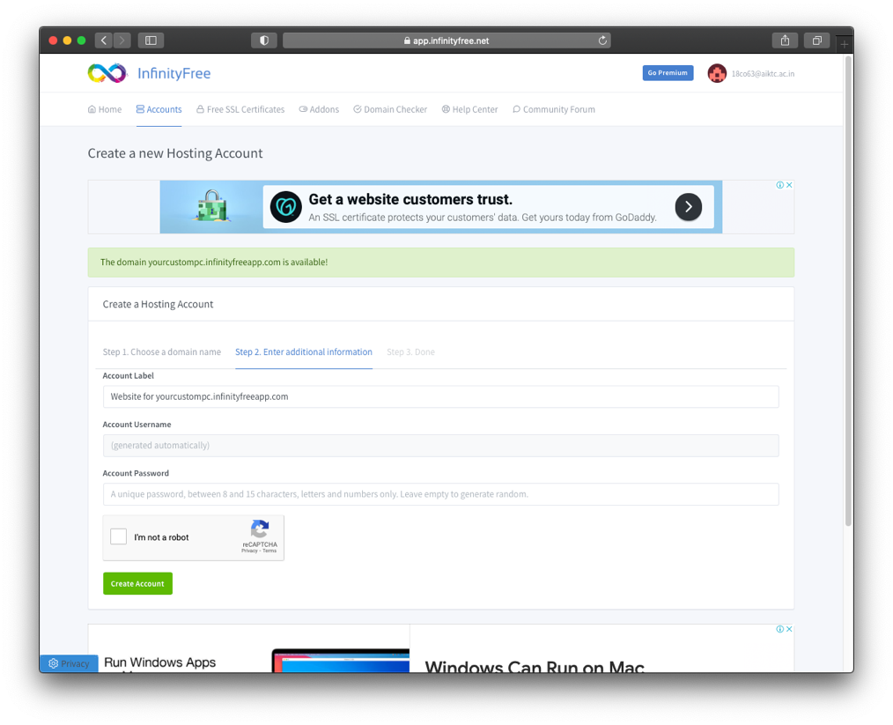

1. **Web Hosting Registration**

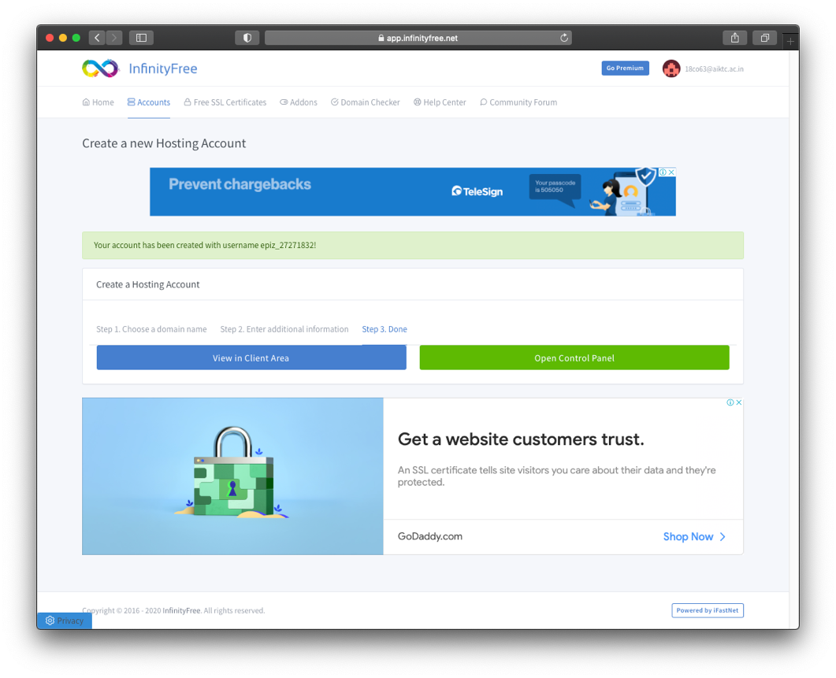

1. **Control Panel**

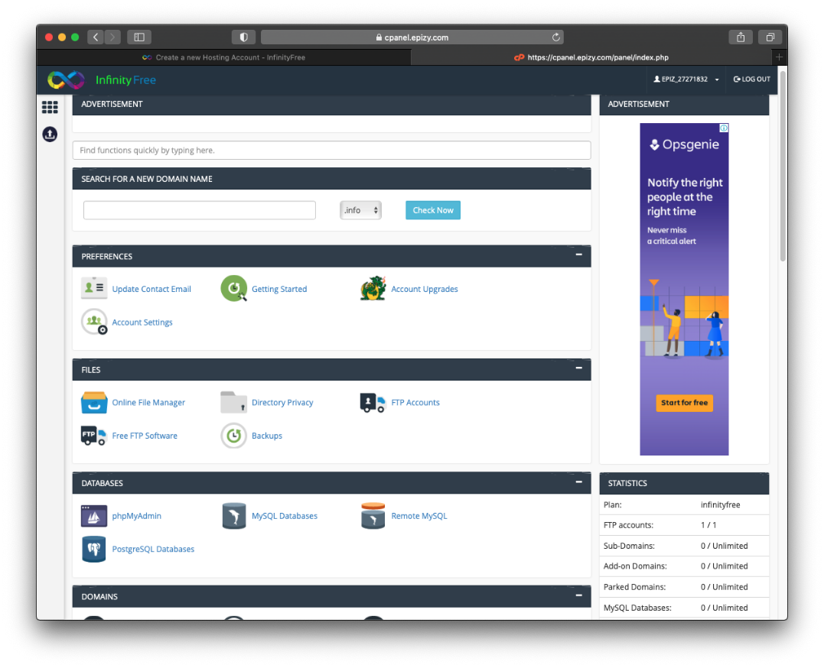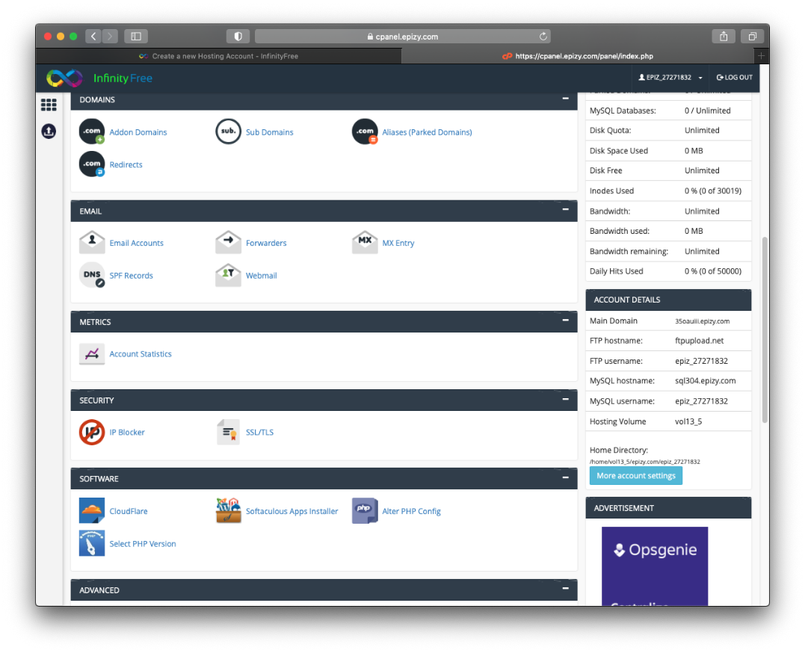

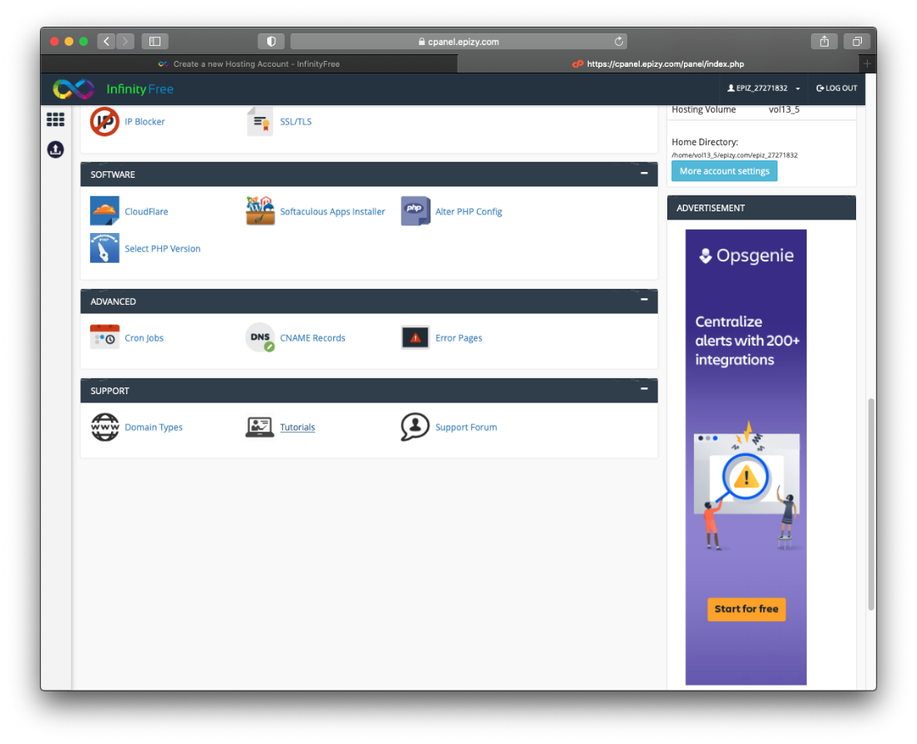

1. **MySQL Database Upload**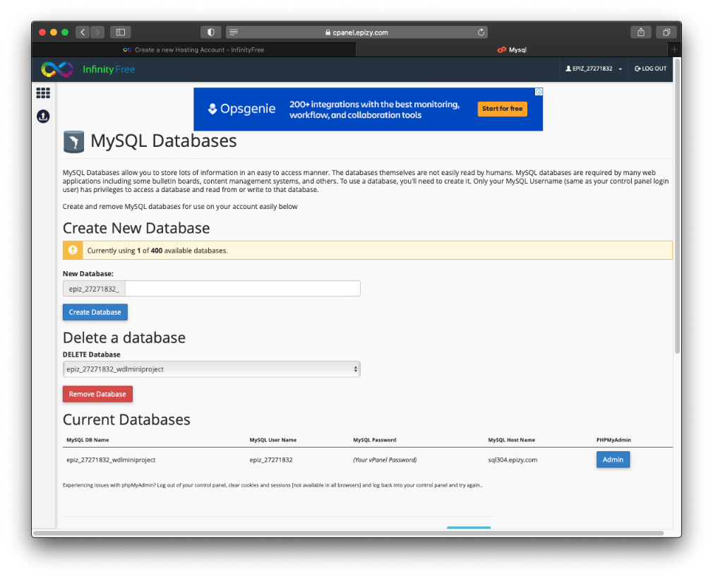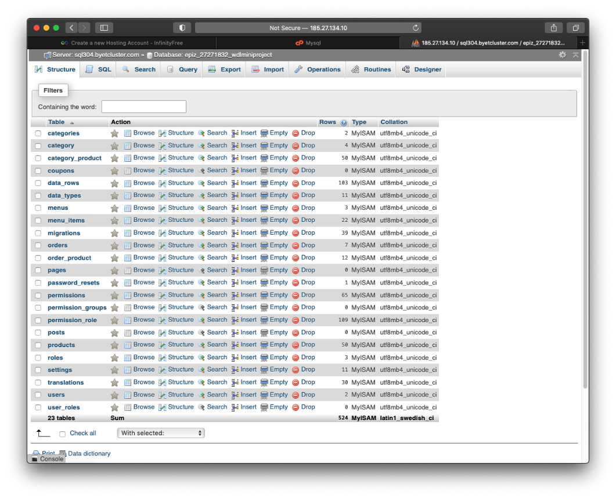
2. **File Manager**

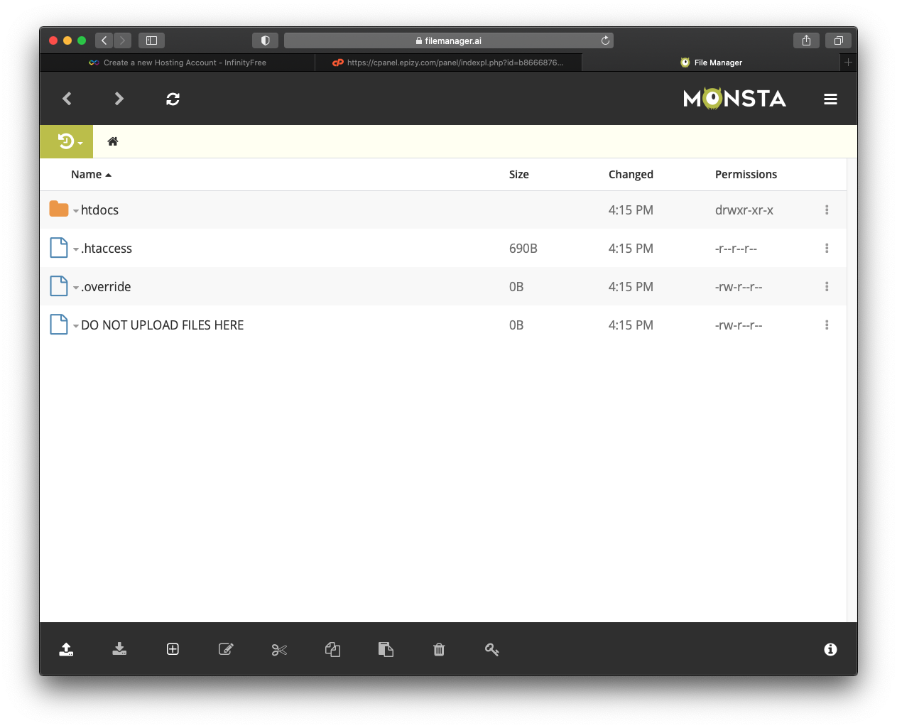

1. **Home page of your domain.**

